**Code Snippets for Paytm code challenge test**

I used **Databricks Community Edition** to execute this below code snippets

1. Sessionize the web log by IP. Sessionize = aggregrate all page hits by visitor/IP during a session.

import org.apache.spark.sql.types._

import org.apache.spark.sql.functions._

import org.apache.spark.sql.expressions.Window

import org.apache.spark.sql.RelationalGroupedDataset

val logDataDF = spark.read.format("csv")

.option("delimiter"," ")

.option("header","true")

.load("/FileStore/tables/2015_07_22_mktplace_shop_web_log_sample.csv")

var logDataFinalDF= logDataDF.withColumn("url", split($"request"," ").getItem(1))

.withColumn("ip",split($"client_port",":").getItem(0)) .withColumn("timestamp",$"timestamp".cast("timestamp"))

.withColumn("time",unix_timestamp($"timestamp", "yyyy-MM-dd hh:mm:ss"))

val sessionWindow = Window.partitionBy(window(logDataFinalDF("timestamp"),"15 minutes")).orderBy(window(logDataFinalDF("timestamp"),"15 minutes"))

var sessionizedDF = logDataFinalDF.withColumn("rn",row_number().over(sessionWindow ))

.withColumn("total_count",max('rn).over(sessionWindow ))

.withColumn("ip_cnt",count("ip").over(sessionWindow ))

.withColumn("url_cnt",count("url").over(sessionWindow ))

.select("user_agent","timestamp","time","url","ip","total_count")

.distinct()

display(sessionizedDF)

Output Screenshot :

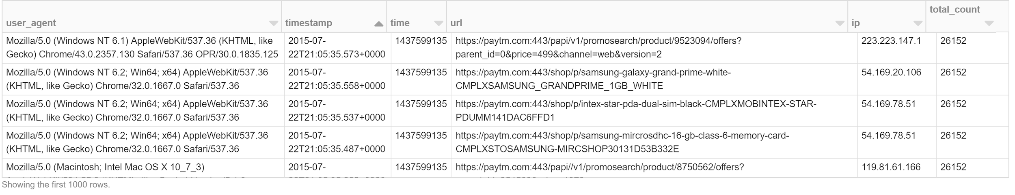

2) Determine the average session time ( deriving users average session time)

val userWindow= Window.partitionBy(logDataFinalDF("user_agent"))

.orderBy(logDataFinalDF("user_agent").desc)

var avgSessionDF = logDataFinalDF.withColumn("rn",row_number().over(userWindow))

.withColumn("total_count",max('rn).over(userWindow))

.withColumn("session_start_time",min(logDataFinalDF("time")).over(userWindow))

.withColumn("session_end_time",max(logDataFinalDF("time")).over(userWindow))

.withColumn("user_session_time",'session_end_time-'session_start_time)

.where("rn=1")

avgSessionDF = avgSessionDF .withColumn("average_user_session_time",'user_session_time/'total_count)

.select("user_agent","average_user_session_time")

display(avgSessionDF)

Output is (average_user_session_time is in seconds) :

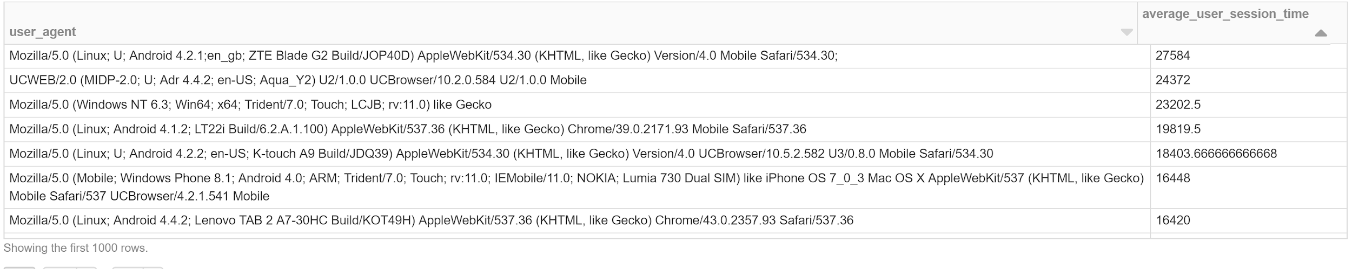

3) Determine unique URL visits per session. To clarify, count a hit to a unique URL only once per session.

var uniqueUrlDF= logDataFinalDF.select("*")

.groupBy(window('timestamp,"15 minutes"),'url)

.count()

var uniqueUrlFinalDF= uniqueUrlDF.select("window","url")

.distinct()

display(uniqueUrlFinalDF)

Output is:

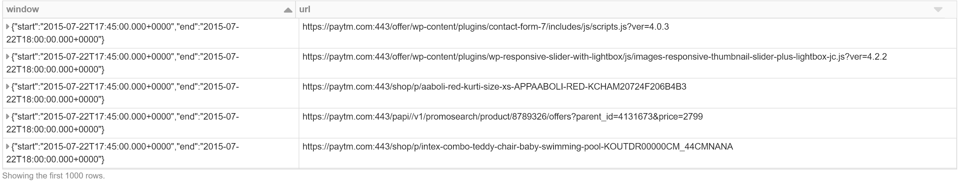

4) Find the most engaged users, ie the IPs with the longest session times

val ipWindow=Window.partitionBy(logDataFinalDF("ip"))

.orderBy(logDataFinalDF("ip").asc)

var ipSessionDF = logDataFinalDF.withColumn("rn",row_number().over(ipWindow))

.withColumn("total_count",max('rn).over(ipWindow))

.withColumn("session_start_time", min(logDataFinalDF("time")).over(ipWindow)) .withColumn("session_end_time",max(logDataFinalDF("time")).over(ipWindow))

.withColumn("ip_session_time",'session_end_time-'session_start_time)

.select("user_agent","ip","ip_session_time","url")

.where("rn=1").orderBy('ip_session_time.desc)

display(ipSessionDF)

Output is:

